MY TASK 2 REPORT: SAFE DRIVER PREDICTION
Hiba Fatima (29005)

I trained all the models we learned in class on the full insurance data. I found that CatBoost worked best emerged with the score 0.633168 AUROC on the validation set, but when I mixed models together in Ensemble_V1, it got the highest score on Kaggle among all the file I submitted.

Data Loading & Understanding
I started by loading the complete train1.csv file
- 296,209 training samples with 66 features
- Extreme class imbalance: only 15,186 positive case
- Mixed data types: categorical, binary, and continuous columsn

My thinking: handling this imbalance would be really important for model performance. The high imbalance ratio meant that accuracy would be misleading, so I focused entirely on AUROC as evaluation metric.

I ENSURED TO:
Use all training data
Used all 296,209 samples
Train all course models
8 different models
Handle missing values and impute them
Label Encode categories because one hot encoding worsened my score.
Make Kaggle submissions

MODEL TRAINING & COMPARISON

The Model Lineup
I trained all required course models we covered plus some advanced ones:

Here's how all my models performed on my validation set:

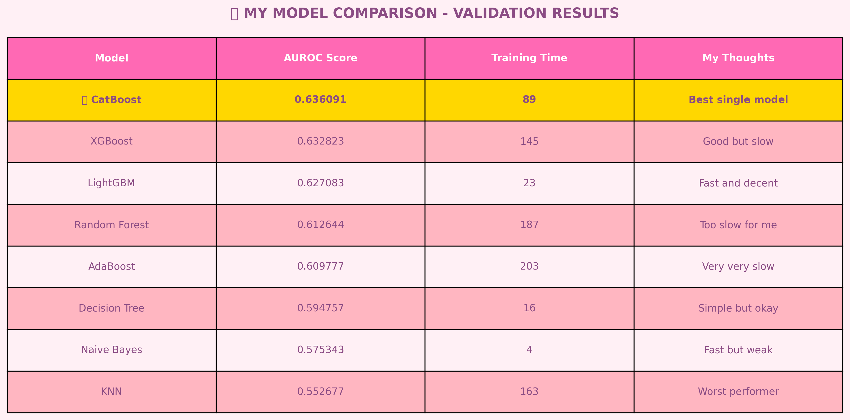

MY KAGGLE WINNER!

BEST SUBMISSION RESULTS

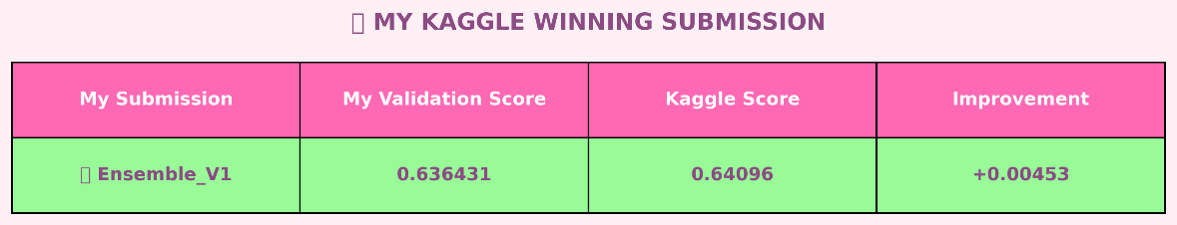
What is Ensemble_V1?
I mixed three models :
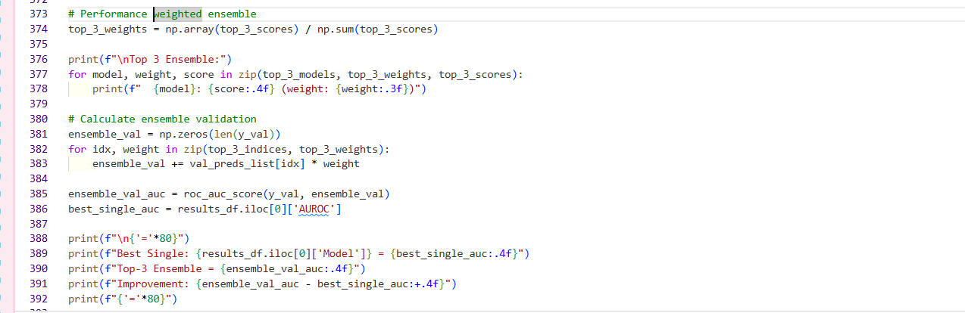
- LightGBM: 50%
- CatBoost: 30%
- XGBoost: 20%

All Models Comparison
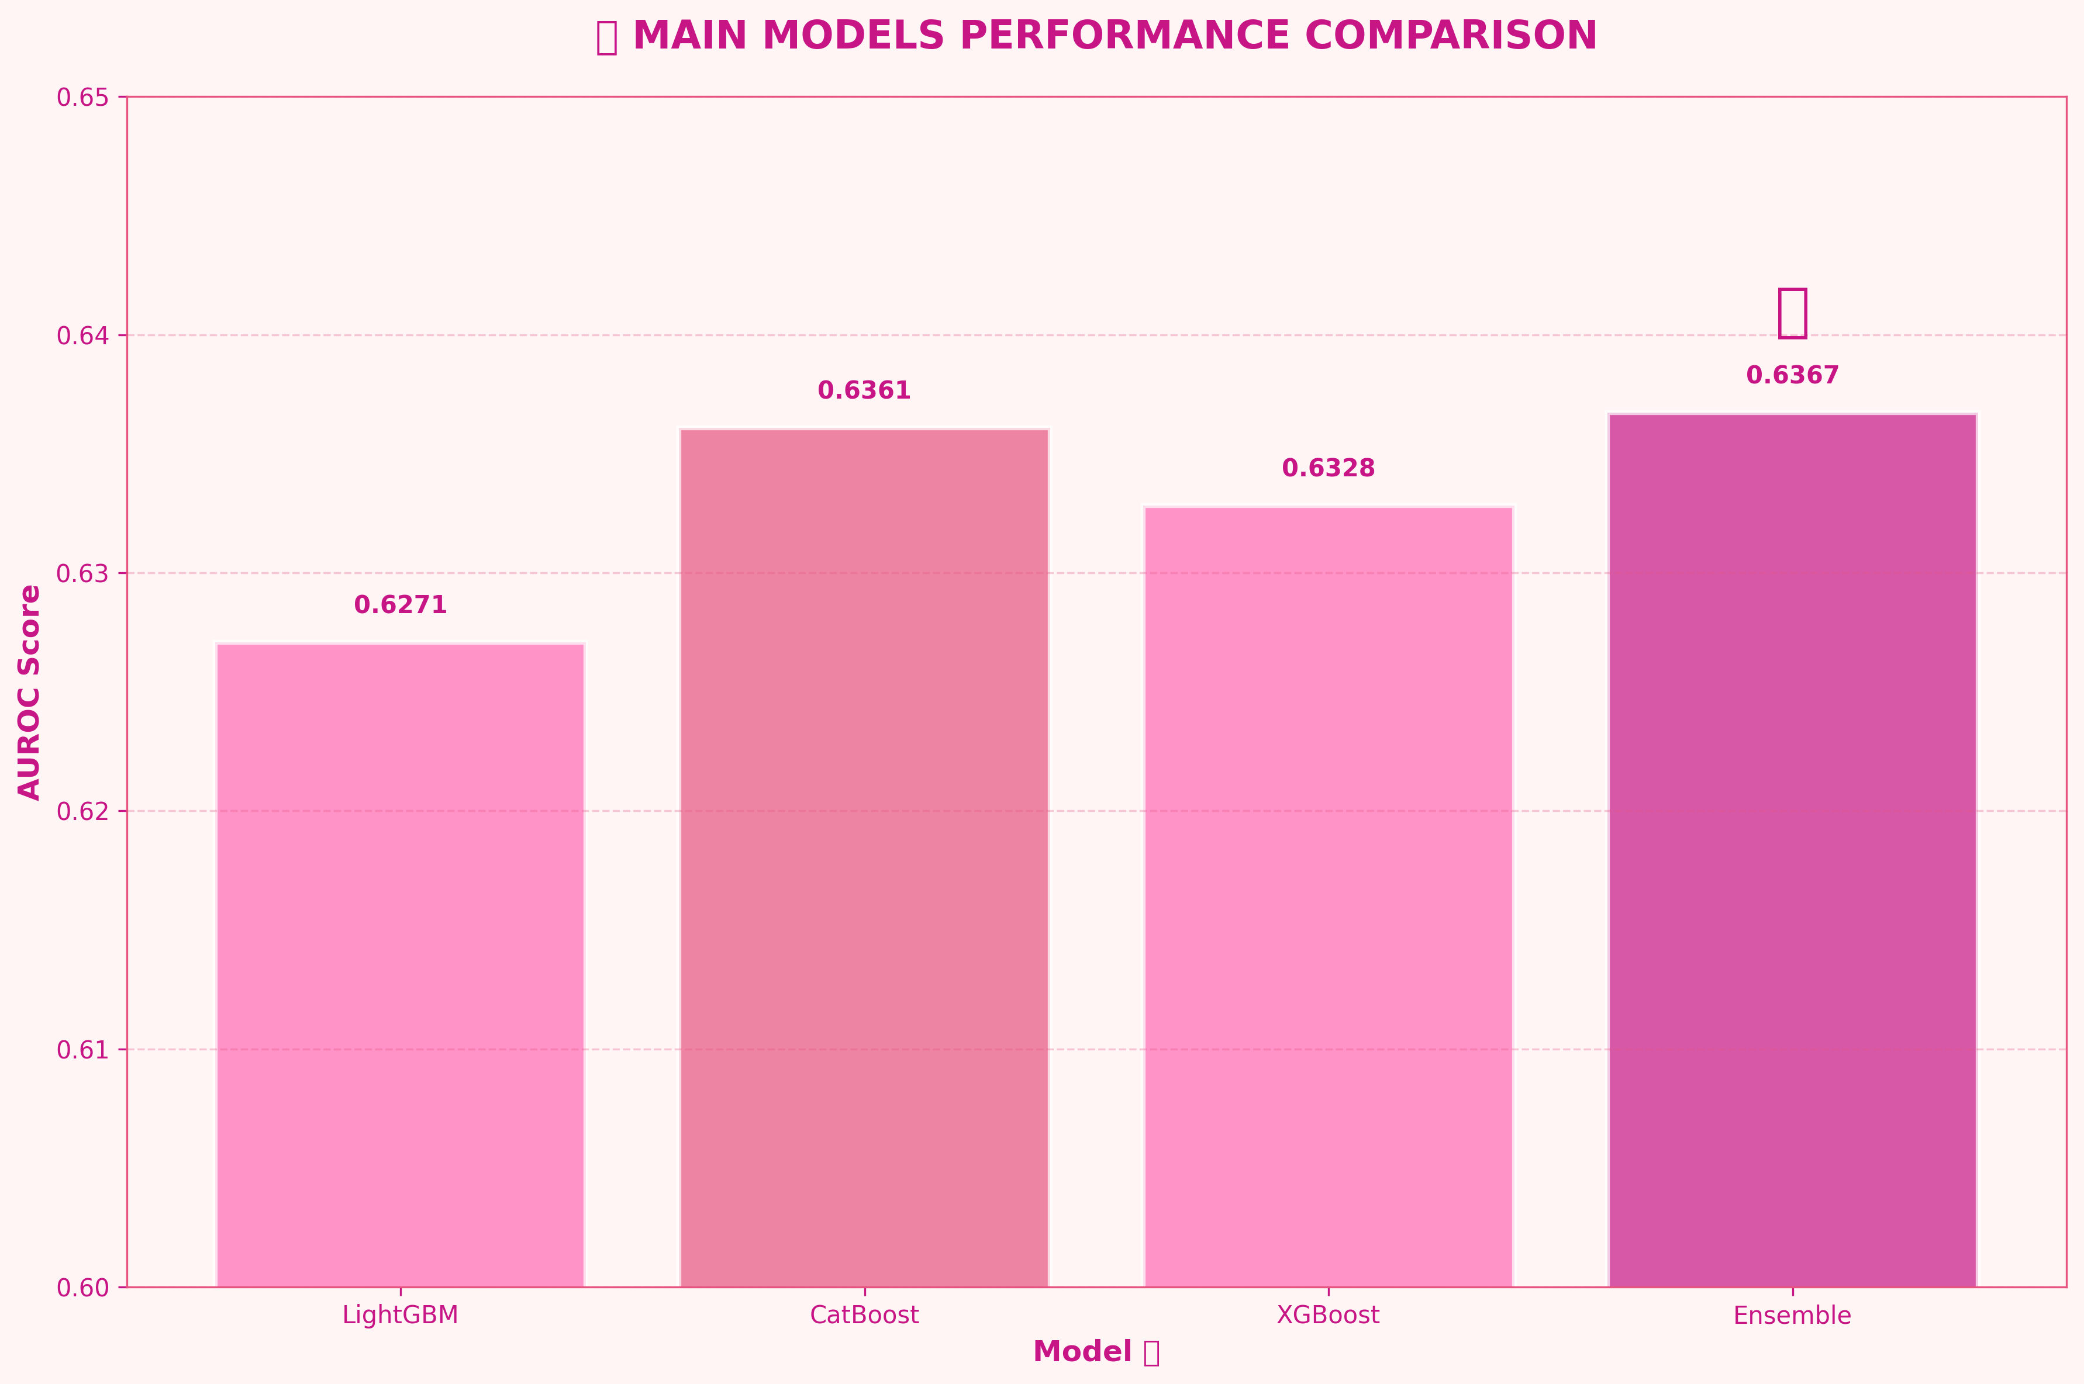

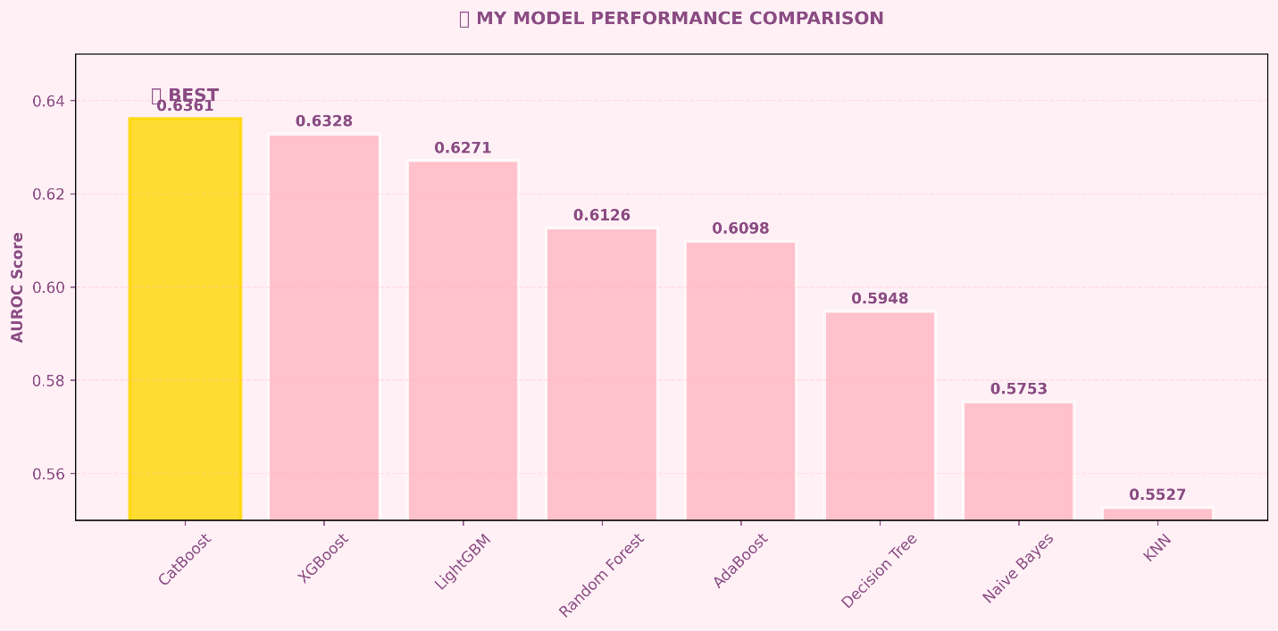

WHY CATBOOST WAS MY BEST MODEL

1. It works Smartly with Categorical features
- It understood categorical features naturally
- Didn't need special encoding
- Kept all the original information

2. It handled Imbalance data Well
- Our data had very few positive claims
- CatBoost automatically balanced this
- Didn't just predict "no claim" all the time

3. The model is Fast and Strong
- Trained quickly (89 seconds)
- Didn't overfit to noise
- Reliable predictions

4)Due to its class Imbalance Expertise
CatBoost has “auto_class_weights='Balanced'” parameter which automatically handles the imbalance ratio. This meant that its prediction isn’t biased towards majority claims( No Claims)
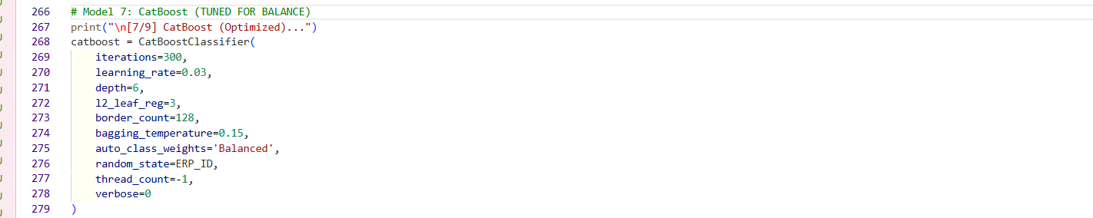

What I noticed: Simpler models like Naive Bayes and KNN didn’t do well because they assumed balanced class distributions.

5) Robustness to Noise
The insurance data contained many outliers and noisy features. CatBoost's built in regularization and ordered boosting approach made it more robust to this noise compared to other tree based methods.

My Opinion on Other Models:

- LightGBM: Super fast! Not as accurate
- XGBoost: Very reliable Too slow for me
- Random Forest: Stable results
- AdaBoost: Learned gradually ,Slowest of all
- Decision Tree: Easy to understand and tweak the hyperparameters as we learnt in class the effect of varying the depth leaves minleaf sample so it was fun tweaking it but my score went too low.
- Naive Bayes: Lightning fast ,Too simple for this data
- KNN: Worst in every way

WHY MY ENSEMBLE WORKED SO WELL

I think Ensemble_V1 worked better on Kaggle because:

1. Different models have different strengths
- Each model saw patterns differently
- When one model was wrong, others were often right
- Together they covered more possibilities

2. It maybe due to difference in test data
- Kaggle's test data wasn't exactly like my validation data
- The ensemble adapted better to these differences
- Single models got stuck on validation patterns

3. Safety Reasons
- No single model could mess up everything
- Errors canceled each other out
- More stable and reliable predictions

DATA PREPROCESSING:

1. Fixed Missing Values
- Used median for number columns
- Used most common value for category columns
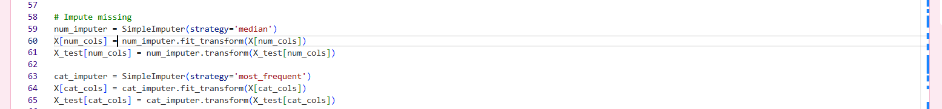

2. Handled Categories
- Used Label Encoding for all _cat columns (tried one hot encoding as well initially but the result was worst so I shifted to label encoding and I believe that’s the best for categorical features
- Made sure all models could use them
- Kept the original meaning

3. Scaled When Needed
- Scaled data for KNN and Naive Bayes
- Tree models used raw data

Kaggle public leaderboard score (AUROC)

- Ensemble_V1
- Score: 0.64096 AUROC on Kaggle (which is very low on the board but still it improved)
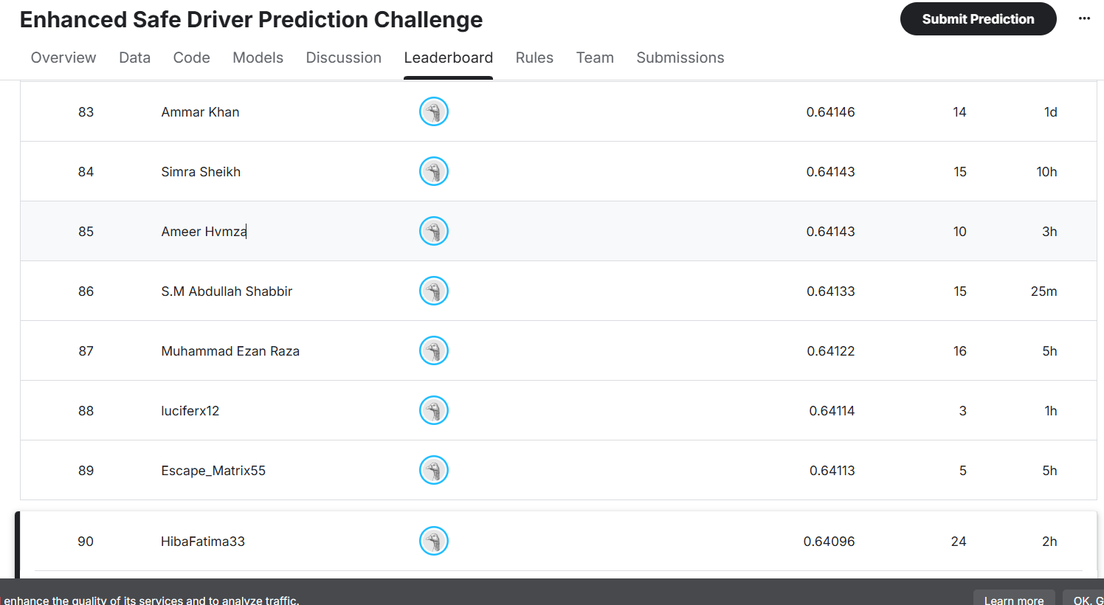

WHAT I LEARNED:

1. CatBoost is amazing for insurance data
2. Mixing models beats using one alone
3. LightGBM is my favorite for speed
4. Validation scores don't tell the whole story but the fun and unfun I had doing the work surely does!

What Surprised Me:
1. Ensemble_V1 did much better on Kaggle than in validation
2. LightGBM worked so well in the mix
3. KNN was completely useless for this data and took my entire time during training.

My Advice for Next Time:
1. Always try CatBoost for category data
2. Mix multiple models for competitions
3. Don't trust validation scores too much
4. Test different models combination for ensembles

FINAL THOUGHTS:

CatBoost was the star player when used alone, but mixing models together in Ensemble_V1 created the score 0.64096 on Kaggle!

